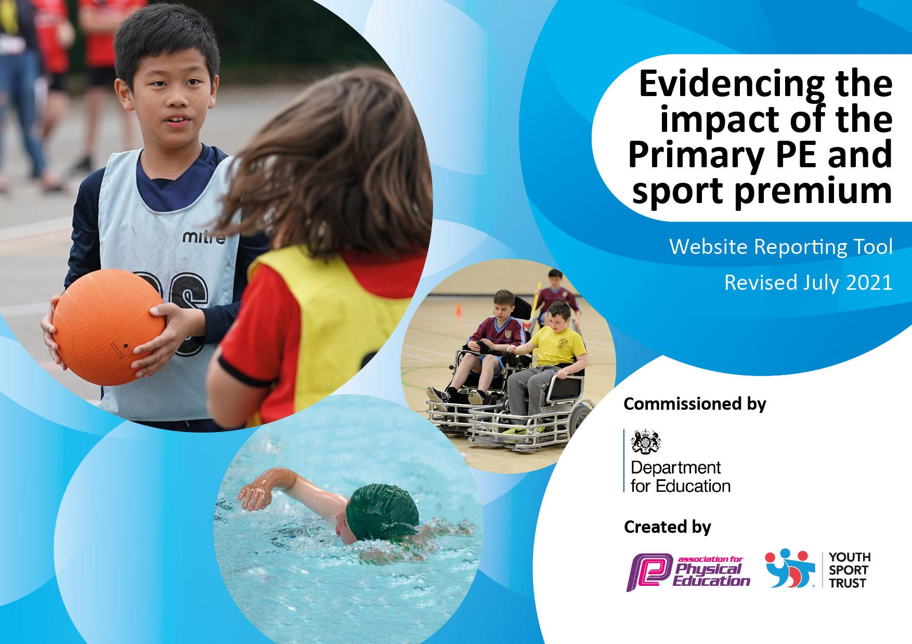
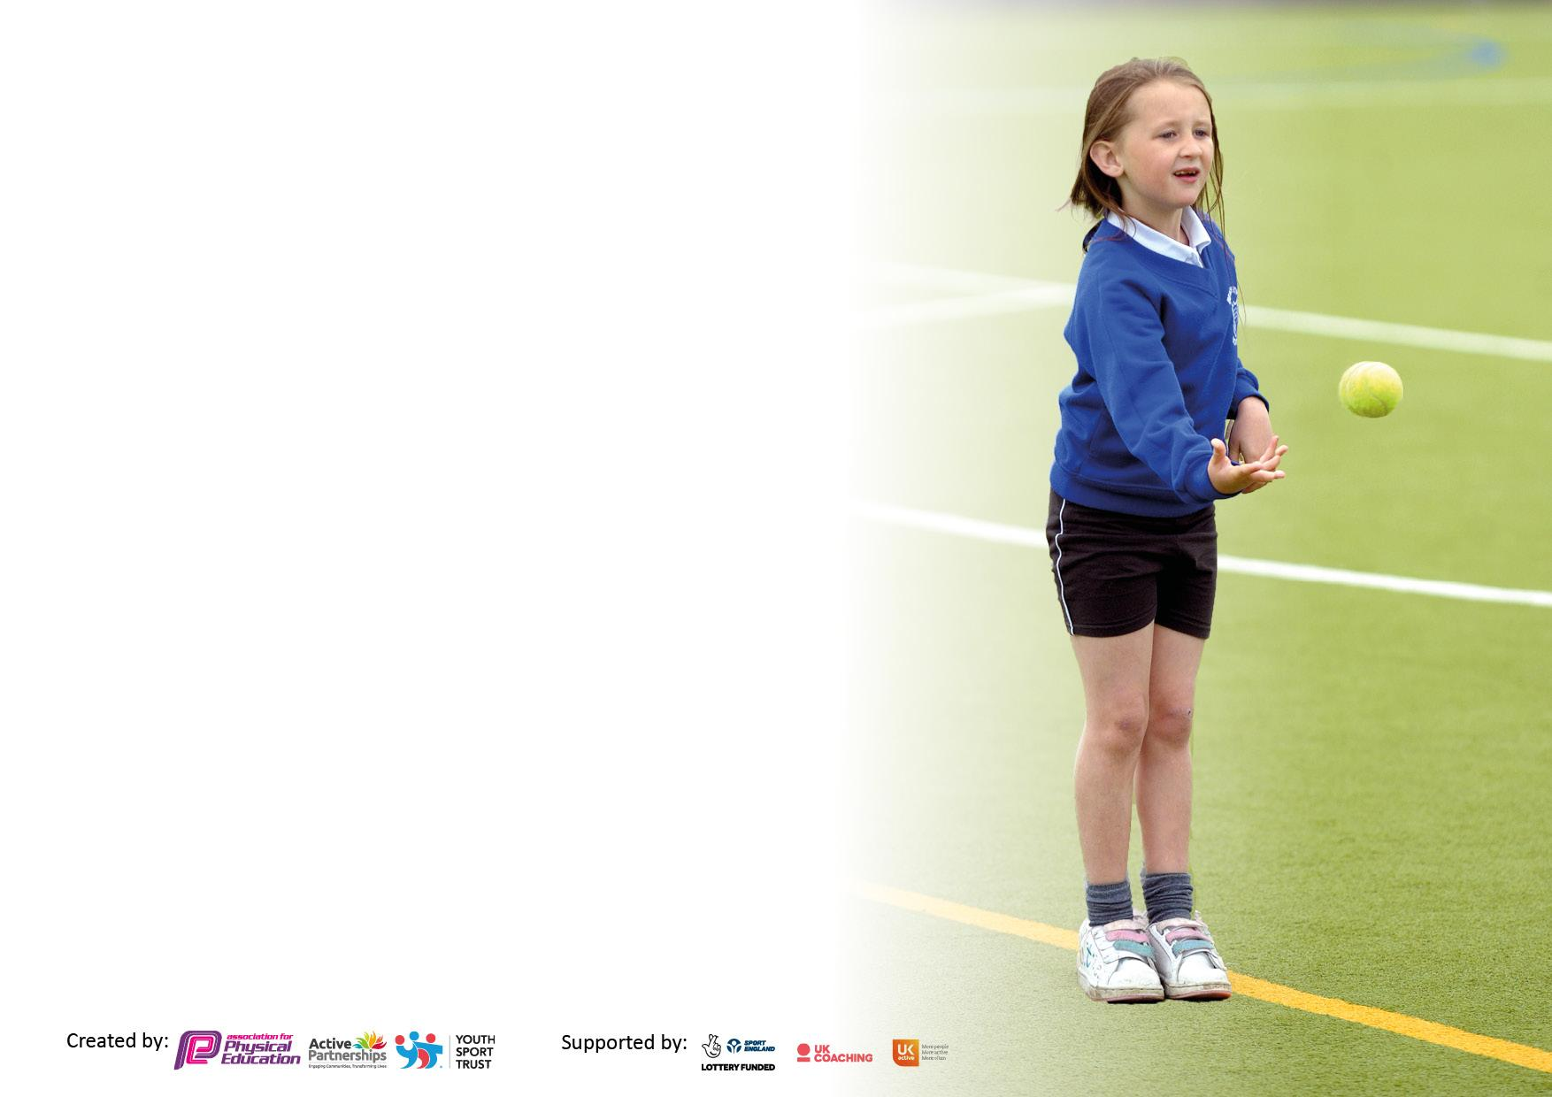

It is important that your grant is used effectively and based on school need. The Education Inspection Framework makes clear there will be a focus on ‘whether leaders and those responsible for governors all understand their respective roles and perform these in a way that enhances the effectiveness of the school’.

Under the Quality of Education Ofsted inspectors consider:
Intent - Curriculum design, coverage and appropriateness
Implementation - Curriculum delivery, Teaching (pedagogy) and Assessment
Impact - Attainment and progress

To assist schools with common transferable language this template has been developed to utilise the same three headings which should make your plans easily transferable between working documents.

Schools must use the funding to make additional and sustainable improvements to the quality of Physical Education, School Sport and Physical Activity (PESSPA) they offer. This means that you should use the Primary PE and sport premium to:

- Develop or add to the PESSPA activities that your school already offer
- Build capacity and capability within the school to ensure that improvements made now will benefit pupils joining the school in future years
- The Primary PE and sport premium should not be used to fund capital spend projects; the school’s budget should fund these.

Pleasevisitgov.ukfortherevisedDfEguidanceincludingthe5keyindicatorsacrosswhichschoolsshoulddemonstrate animprovement.Thisdocumentwillhelpyoutoreviewyourprovisionandtoreportyourspend.DfEencouragesschools to use this template as an effective way of meeting the reporting requirements of the Primary PE and sport premium.

We recommend you start by reflecting on the impact of current provision and reviewing the previous spend.

Schools are required to publish details of how they spend this funding, including any under-spend from 2020/2021, as well as on the impact it has on pupils’ PE and sport participation and attainment. All funding must be spent by 31st July 2022.

We recommend regularly updating the table and publishing it on your website throughout the year. This evidences your ongoing self-evaluation of how you are using the funding to secure maximum, sustainable impact. Final copy must be posted on your website by the end of the academic year and no later than the 31st July 2023. To see an example of how to complete the table please click HERE.
Created by: Supported by:

Details with regard to funding
Please complete the table below.

Total amount carried over from 2020/21 | £0
Total amount allocated for 2021/22 | £20,510
How much (if any) do you intend to carry over from this total fund into 2022/23? | £0
Total amount allocated for 2023/24 | £21640
Total amount of funding for 2023/24. To be spent and reported on by 31st July 2023. | £21640

Swimming Data
Please report on your Swimming Data below.

Meeting national curriculum requirements for swimming and water safety.  N.B. Complete this section to your best ability. For example you might have practised safe self-rescue techniques on dry land which you can then transfer to the pool when school swimming restarts.  Due to exceptional circumstances priority should be given to ensuring that pupils can perform safe self -rescue even if they do not fully meet the first two requirements of the NC programme of study | As part of our extended curriculum children learn about water safety and associated dangers.
What percentage of your current Year 6 cohort swim competently, confidently and proficiently over a distance of at least 25 metres?  N.B. Even though your pupils may swim in another year please report on their attainment on leaving primary school at the end of the summer term 2020.  Please see note above | Current year 6 swimming at a distance of at least 25m = 65%  current year 4 swim 25m = 71%
What percentage of your current Year 6 cohort use a range of strokes effectively [for example, front crawl, backstroke and breaststroke]?  Please see note above | Current year 6 performing a range of recognisable strokes = 20%  current year 4 perform a range of recognised strokes = 51%
What percentage of your current Year 6 cohort perform safe self-rescue in different water-based situations? | Current year 6 perform a safe rescue = 61%
Schools can choose to use the Primary PE and sport premium to provide additional provision for swimming but this must be for activity over and above the national curriculum requirements. Have you used it in this way? | No

Action Plan and Budget Tracking
Capture your intended annual spend against the 5 key indicators. Clarify the success criteria and evidence of impact that you intend to measure to evaluate for pupils today and for the future.

Academic Year: 2022/2023 | Total fund allocated: | Date Updated: July2023
Key indicator 1: The engagement of all pupils in regular physical activity – Chief Medical Officers guidelines recommend that primary school pupils undertake at least 30 minutes of physical activity a day in school |  |  |  | Percentage of total allocation:
 |  |  |  | %
Intent | Implementation |  | Impact
Your school focus should be clear what you want the pupils to know and be able to do and about what they need to learn and to consolidate through practice: | Make sure your actions to achieve are linked to your intentions: | Funding allocated: | Evidence of impact: what do pupils now know and what can they now do? What has changed?: | Sustainability and suggested next steps:
In a week, pupils to participate in 60-minute physical education lesson, 30 minutes physical missions as part of the Trust WOW curriculum, 45 minutes physical activity during break/lunch using equipment provided, plus attend sports clubs after school.  Implement themed days tailored to improving physical activity engagement.  To participate in local sporting initiatives such as inter Trust competitions.  To ensure that teaching of PE is of a high standard – All pupils to access weekly PE sessions  To ensure that all pupils are active for at least 30mins per day during planned lunchtime sessions  Fundamental movement skills to be made clear through focussed activities, as outlined within the curriculum  To develop pupil voice activities - sport council representatives inform decision making/provides leadership opportunities  Maintain involvement and participation in local events and make key contacts within the local community to further enhance the curriculum offer (Manchester PE Association) | CPD for all lunchtime staff - how to effectively promote physical activity throughout the lunch time period, including the purchase of resources  Specialist (Premier) coaches will support staff in providing access to physical and sporting activities during the lunchtime sessions  Investment in updating equipment available during curriculum time and during breaks and extra-curricular activities  Manchester PE Association membership | Coaches- £18,000  Resourcing £1500  Curriculum  Enrichment – £11.873  £1500  £1800 | Improved range of physical and sporting activities available for the children during lunchtimes.  Staff training has supported the lunchtime staff in developing an understanding of the importance of physical activity.  All children have accessed PE sessions and after school clubs led by a specialist coach  Pupil Voice/sports council meeting records demonstrate input into extended curriculum offer – children understand why physical activity is important for their wellbeing | Revise the use of ‘sports councils to suit the running of lunch times to improve children’s physical activity
Key indicator 2: The profile of PESSPA being raised across the school as a tool for whole school improvement |  |  |  | Percentage of total allocation:
 |  |  |  | %
Intent | Implementation |  | Impact
Your school focus should be clear what you want the pupils to know and be able to do and about  what they need to learn and to  consolidate through practice: | Make sure your actions to achieve are linked to your intentions: | Funding allocated: | Evidence of impact: what do pupils now know and what can they now do? What has changed?: | Sustainability and suggested next steps:
Active missions provided across the school to further promote physical activity.  PE coach to work alongside teachers in planning and delivering the PE curriculum  Across all year groups, implement ‘Know Statements’ to ensure curriculum objectives are met and revisited if any misconceptions | Curriculum enrichment leads support teachers in delivering active missions.  Premier coach delivered SEMH interventions through physical activity.  PE Trust Lead created ‘Know Statements’ which are now being used in PE lessons being taught each week. | £11,873 | Active missions improving pupils wellbeing, social and emotional needs as well as overall fitness  Children who require intervention with SEMH needs are gaining valuable experience and techniques in supporting their emotional regulation during situations (sport) where emotions are heightened  Teachers are becoming more confident to teach PE with a clear focus on learning outcomes | SEMH interventions to be focus during lunch time sessions with premier coach for all pupils

Key indicator 3: Increased confidence, knowledge and skills of all staff in teaching PE and sport |  |  |  | Percentage of total allocation:
 |  |  |  | %
Intent | Implementation |  | Impact
Your school focus should be clear | Make sure your actions to | Funding | Evidence of impact: what do | Sustainability and suggested
what you want the pupils to know | achieve are linked to your | allocated: | pupils now know and what | next steps:
and be able to do and about | intentions: |  | can they now do? What has
what they need to learn and to |  |  | changed?:
consolidate through practice:
Children are equipped with a wealth of knowledge from the curriculum with fundamental movement skills  taught from an early age to provide a  measure of clear progression throughout school.  PE is accessible for all and is instrumental in supporting mental health and wellbeing alongside the extended WOW curriculum offer.  Teachers to effectively assess progress  Children access good quality sports coaching  Teachers receive high quality CPD weekly to enable them to build confidence and skills to deliver high quality physical education lessons. | Specialist coach to deliver PE sessions daily alongside lunchtime and afterschool activities.  Complete PE subscription supports staff in developing their subject knowledge and planning – alongside ‘Know Statements’  PE Lead to deliver CPD sessions – curriculum content, how does knowledge and skills in PE develop/progress | £18,000  Complete PE | Staff have been supported by a trained coach who demonstrates good practice in delivering high quality PE lessons  Staff are developing confidence in their knowledge of the curriculum and the delivery of PE sessions.  Children enjoy accessing PE sessions and are making further progress in the development of fundamental skills. | Staff to work alongside specialist coaches in team teaching (CPD)  PE lead to review and amend Know statements based off feedback document from Class teachers / Premier coach
Key indicator 4: Broader experience of a range of sports and activities offered to all pupils |  |  |  | Percentage of total allocation:
Intent | Implementation |  | Impact
Your school focus should be clear | Make sure your actions to | Funding | Evidence of impact: what do | Sustainability and suggested
what you want the pupils to know | achieve are linked to your | allocated: | pupils now know and what | next steps:
and be able to do and about | intentions: |  | can they now do? What has
what they need to learn and to |  |  | changed?:
consolidate through practice:
Extra-curricular clubs - Source external providers/local providers to provide extra-curricular sporting opportunities and highlight provision available within the local community. | Specialist coaches to deliver a sports club daily after school.  Teachers to deliver Sport specific clubs throughout the terms.  Links to be made within the local community to further promote a range of sports and activities  Pupils and families to be aware of sporting opportunities available within the local community promoting physical health and wellbeing.  Heighten profile and expose pupils to variety of sports through visitors, trips, assemblies  Sports council/play leaders promoted participation in activities during break/lunchtimes | Premier - £18,000  Curriculum Enrichment – £11.873  MPEA - | Extracurricular clubs delivered by specialist coach have been offered to all year groups throughout the year  Partnership with Bikeability and MCRactive swimming  SEMH sport intervention run by premier coach involving physical activity and RESPECT values | Further develop enrichment offer.  Continue to become more involved in the community, making pupils and families aware of provision/facilities available

Key indicator 5: Increased participation in competitive sport |  |  |  | Percentage of total allocation:
 |  |  |  | %
Intent | Implementation |  | Impact
Your school focus should be clear | Make sure your actions to | Funding | Evidence of impact: what do | Sustainability and suggested
what you want the pupils to know | achieve are linked to your | allocated: | pupils now know and what | next steps:
and be able to do and about | intentions: |  | can they now do? What has
what they need to learn and to |  |  | changed?:
consolidate through practice:
Children have access to a comprehensive and regular programme of competition enabling them to compete against other schools.  Transport to be available to attend competitions out of school grounds | Children to take part in sporting competitions through the Manchester PE association, as well as competing with Trust schools and other schools within the local area.  Children to take part in sports at Regional events venue | MPEA £1800  Coaches/taxis: | Trust football competitions organised and successfully completed. | Develop further opportunities for children to take part in competitive sporting events  Seek sponsorship/opportunities for those with higher level talent.

Signed off by
Head Teacher: | C.Hall
Date: | 24.07.23
Subject Leader: | Jessie Dooley
Date: | 24.07.23

