Dear Parent/Carer,
Year 3 – Newsletter
Welcome Back
A massive welcome back and happy new year to all of our students, parents and carers! We hope you had a well-rested break and are looking forward to the year ahead.
Curriculum
This term, Year 3 will be focusing on reading, writing and maths in our morning sessions and topic learning in the afternoon. We follow the Read Write Inc. scheme for both phonics boosters and our spellings lessons.

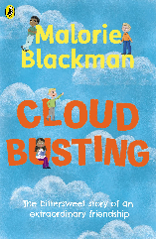
Science: This half term, we will be learning all about forces and magnets. We will learn different types of contact and non-contact forces and the impact friction has on different surfaces. In Spring 2, we will be learning all about plants. We will be learning about the requirements of plants for growth. We will also learn about the functions of the parts of a plant and the flower for fertilisation.
Geography: In Spring 2, we will be focusing on mountains and volcanos in Italy. We will look at what the names of the different mountains and mountain ranges.
History: In Spring 1, we will be learning about the Ancient Egyptians. We will look at the beliefs of the ancient Egyptians and the process of mummification.
RE: Year 3 will continue to look at churches and their features. We will focus on Christianity in London and the history of St Pauls cathedral.
Art: We will be learning about and exploring Egyptian Art, focusing on the artist Rosa Bonheur. We will design and create our own Egyptian mask and then an Egyptian pendant in Spring 2.
Music: This term we are very lucky to continue to have music teachers Mrs Buckler/Mr Jones, who will work with us every two weeks on our music skills (singing, listening and appraising, composing and performing).
RESPECT & WOW: Year 3 will be learning all about Ernest Shackleton as part of their RESPECT curriculum! Ernest Shackleton was a polar explorer who travelled the Antarctic with a small team. The children will learn all about his adventure and any difficulties that he would have faced. Ernest Shackleton used a lot of the values that our school curriculum is based around. In addition to this, the children will be taking part in mindfulness lessons as well WOW sessions which focus on wellbeing and self-care.
Class Reading: During DEAR time this half term, the children will be read ‘Charlie Changes into a Chicken’ by Sam Copeland and ‘The Butterfly Lion’ by Michael Morpurgo. We will also read Cloud Busting by Malorie Blackman and The Spiderwick Chronicles by Toni DiTerlizzi. At the end of Spring term, we will also have our second poetry recital of the year.
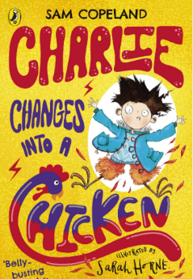
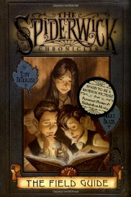
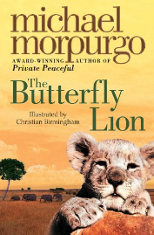

Home Learning: To help support your child at home, we encourage parents to read with their child 3 times per week and sign their reading record diary with a date and signature. Frequent reading will enable your child to increase their language fluency, comprehension skills and reading stamina and will help with all areas of the curriculum. Please send your child in daily with their book bags, reading book and reading record.
The children will also choose a class library book to take home for parents/carers to read with them for pleasure.
Another excellent way to support your child at home is by practising spelling their high frequency words or practising the spelling rule they are being taught that week. Spelling homework will be handed out every Friday and should be returned by the following Wednesday.
This year we will also be reciting our x3, x4, and x8 tables, so any recall practise at home will support the children for next year when they will complete the Year 4 Times Tables test. In this test they will need to be able to recall times tables facts up to x12 quickly and confidently.

General Information
Water bottles – please send your child in with a reusable water bottle with your child’s name clearly marked. The children have access to these at all times during the school day and keeping hydrated is really important. Polite reminder – please only send water in your child’s bottle. Fizzy drinks and strong juice are not allowed as we are a healthy school.
PE – PE kits are not provided by the school. Please provide your child with a plain white t-shirt and either blue or black plain shorts. The children will also be required to bring in a pair of sensible shoes to participate in outdoor lessons. You can send your child in with a pair of shoes to keep in their lockers throughout the week.
Each class has a PE day on the following days:
3LW – Wednesday
3KN – Wednesday
3EC – Wednesday

Our Year 3 Team –

Class Teachers: Miss Newton, Miss Cooper and Miss Winder
Teaching Assistants: Mrs Rigby, Miss Lewis and Miss Bolger
Computing - Miss Rawling
Music - Mrs Buckler/Mr Jones

Key Stage Lead – Mrs Buckley and Miss Shaw

